**Master Piece-Project 10**

Technical Documentation

Coding Academy by Orange – Irbid

BoyoutKom-Real estate agency website

Tasnem Baibars

Table of Contents

**Abstract1**

Introduction & brief2

Users cycle3

**Technology & Tools[1]4**

Users Permissions5

Database-Schema6

Project Brief

Regarding the annual increase in the market demand for housing units,

Based on the annual population increase**,** the current population of **Jordan** has

reached **10,418,051** as of Thursday, August 18, 2022.

And based on a study has been held in 2018 (The Economic and Sector Work )

Concluded that “Over the next decade, **Jordan** will need to produce between **62,000**

**to 74,000** housing units annually to reduce the current deficits and keep up with new

household formation”.

A study that occurred in 2017 under the study (The Construction & Housing Sector

in Jordan) noted that the total number of construction enterprises has increased

from 1,531 in 2006 to more than 3,000 by the end of 2017.

BoyoutKom is a start-up real estate agency company aiming in finding an easy

journey for a customer to find his appropriate property & affording a fully

automated promoting method for an estate owner.

Introduction

BoyoutKom came to facilitate the process of Renting -Selling -Buying an estate.

BoyoutKom is an automated searching platform for estates based on estate categories -price ranges – neighborhoods – specifications.

Users Cycles :

Admin :

Admins have the entire permission for managing the whole website (added estates, users, feedback & any future updates would be held next).

Estate Owner:

Estates owners have permission to view the whole website

Added to this they can add, view, edit & delete their own estates.

Users:

Users can view the whole estate added to the website and contact the admin page or the estate owner based on the contact information that has been left in every estate, also they can leave feedback on the estate and their journey on website

Technologies and Tools:

* Figma
* GitHub
* Visual studio
* HTML-CSS
* Laravel
* MYSQL (database)

Data Base Schema :

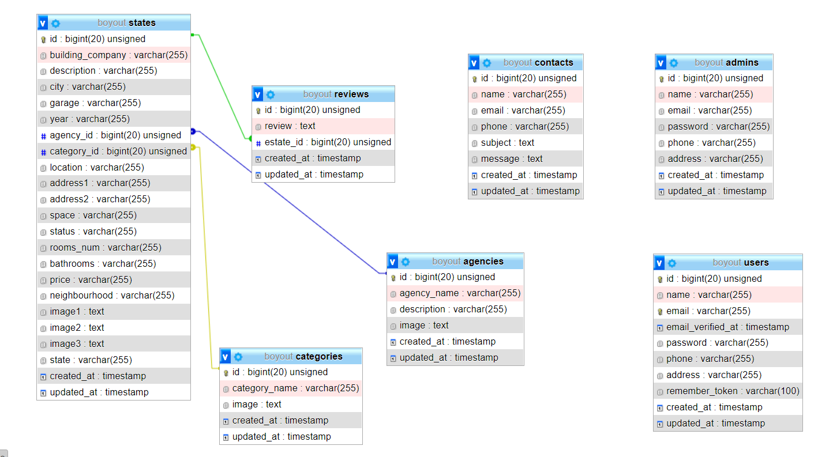

Pages :

* Home page
* Hero Image
* Action Button
* Filters
* Categories
* Few estates
* All properties
* View all properties in the website
* Single Property
* Detailed every single property
* Contact information
* Review section
* User profile
* User Info
* Estates added by the user
* Add - Edit & Delete

Admin Dashboard:

* Users
* View-Add -Edit & Delete users
* Admins
* View-Add -Edit & Delete admins
* Categories
* View-Add -Edit & Delete categories
* Estates
* View-Add -Edit & Delete estates

1.